Interplast & Rotary

A GOOD NEWS STORY FOR 40 YEARS years

*“Frezole will be willing to go to school because of his good health. Frezole aims to be a doctor because of his experience with this sickness. As a mother, I really appreciate this operation. His health makes me really proud”.*

Frezole’s ongoing care will be monitored by the team at the National Referral Hospital in Honiara. With continued support for their critical work, Interplast intends to return to follow up with patients like Frezole and treat more children who require care.

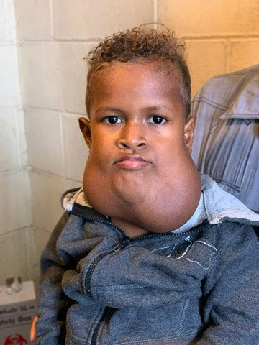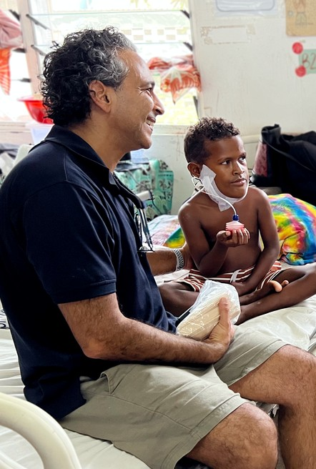

**Interplast's surgical team first met two-year-old Frezole in 2017.** He was diagnosed with a severe lymphatic mass malformation in his lower jaw, which he has lived with since birth. Unfortunately, children with disfiguring conditions often face prejudice in their communities. Bullying often prevents them from attending school. Meanwhile, their families struggle with the financial burden of diagnosis and treatment.

Due to the absence of specialised plastic surgeons in Solomon Islands, Frezole did not receive any medical intervention until 2019, when the Interplast team was finally able to treat him. Visiting Interplast teams play a critical role in providing transformative plastic and reconstructive surgery to children like Frezole, who would otherwise lack access to this essential care.

This year, during Interplast's most recent visit to Solomon Islands,

Dr Zac Moaveni and Dr Jarrad Lilygeto successfully removed the mass from Frezole's face. Frezole’s mother Joylyn is overwhelmed by the change for her son.

Frezole before surgery in 2019

This visit marked Interplast's first return to Solomon Islands since overseas programs were suspended in 2020 due to COVID-19. Dr Scott Siota expressed his satisfaction at the opportunity for Interplast teams to reconnect with patients like Frezole.

*“… Over the past years accumulated and these patients have been frequently visiting our clinics just to ask on when Interplast team will come, so their children could have surgery…” (sic)*

Since 1983, Rotarians have raised significant funds to support Interplast in repairing bodies and rebuilding lives. Forty years of critical support to provide life-changing surgeries in Asia Pacific countries have seen an incredible impact for families and children like Frezole.

**Rotary Clubs of District 9930 in New Zealand were instrumental in the funding of this visit to Solomon Islands. A sincere thank you to all the Rotarians and Clubs who contributed to this program.**

Dr Zac Moaveni and Frezole after surgery 2023

interplastanz interplastanz

[www.interplast.org.au](http://www.interplast.org.au/) [www.interplast.org.nz](http://www.interplast.org.nz/)