ROTARY & INTERPLAST
a GOOD NEWS story for 40 years

2023 marks the 40th anniversary of Rotary co-founding Interplast.
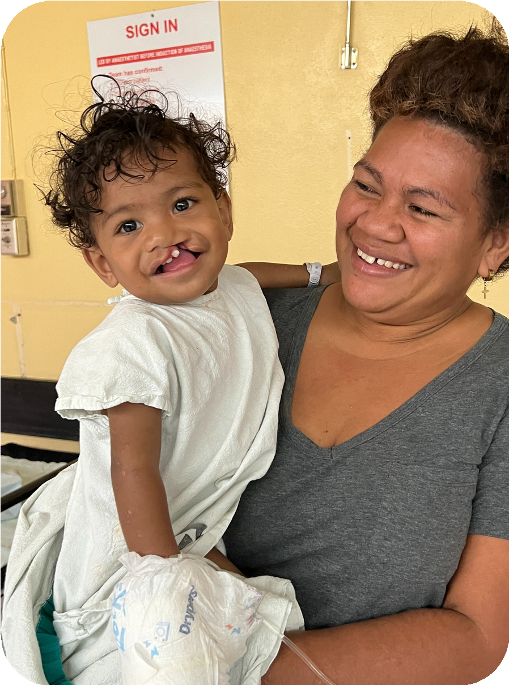Since 1983, Interplast and Rotary have changed thousands of patients' lives and trained hundreds of clinicians in developing countries.
In November 2022, Interplast's first volunteer surgical team to travel since the Covid-19 pandemic began, visited Labasa and Suva in Fiji. 31 surgeries were performed on 29 patients, including 1-year old Moceiwai, who was born with a cleft lip and palate.
For 12 months, Moceiwai and his mum, Loata, had endured 3-hour return bus trips from their village to the Labasa hospital, sometimes daily, to receive treatment or have his feeding tube replaced. The logistics and the expense of the constant trips took a significant toll on the whole family.
In November last year, Loata received wonderful news. The treatment she had been praying so hard for was a possibility. The Interplast team arrived at the Labasa Hospital. “Dr David came, the same day, he just came and listened to his heart, and he just told me everything is clear. And I thank God, and he told me, he will be the one, he will be the first case tomorrow morning”.

After a year of managing Moceiwai’s condition, Loata was ready to entrust her baby to the Interplast team for his first life-changing surgery. “I give him to Dr Simone, I was crying, and she just told me ‘Don’t worry, we’re going to take of your baby, I promise'.“
In a 4-hour operation, Moceiwai's cleft lip was successfully repaired. Loata's anxious wait turned to tears of joy when she saw her son after the surgery. “I call my husband and my husband came, he just look at him and we were crying. I just standing there and thank God, without those team, the Interplast team, nothing can be done like this”.
The next step for Moceiwai and his family is his cleft palate operation. A cleft palate, if unrepaired, impacts on the ability to eat, speech, hearing, growth, development and general health. Infections are common, requiring more trips to hospital and ongoing expenses.
Interplast volunteers will return to Labasa in 2023, and the plan is to repair Moceiwai's cleft palate then.
Interplast's 145th visit to Fiji was majority-funded by Rotary District 9675 in Australia. A sincere thank you to all the Rotarians and Clubs who contributed to this program.
Interplast and Rotary – changing lives together for 40 years.
interplastanz
interplastanz
www.interplast.org.au
www.interplast.org.nz
Moceiwai & his Mum Loata before his surgery

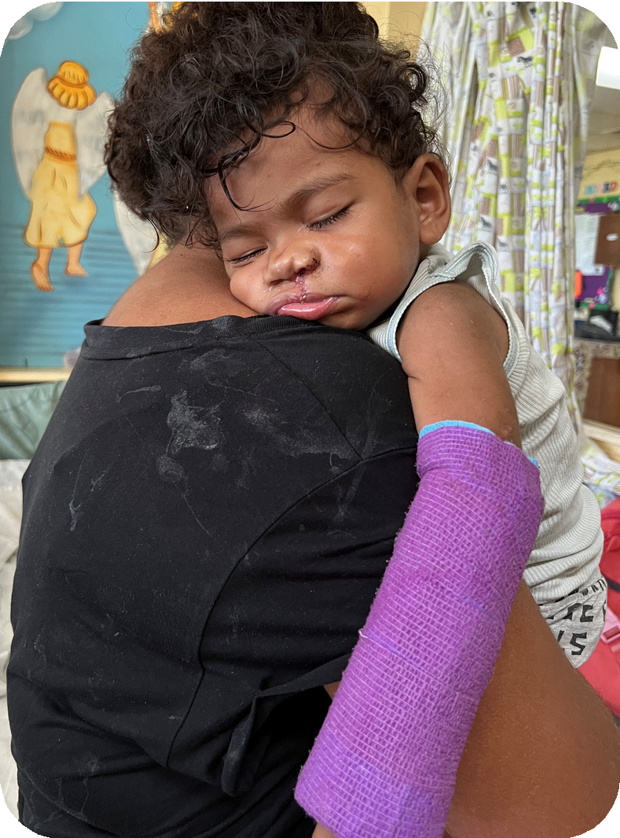
Moceiwai sleeping in his mum's arms after surgery

