Rotary & InTERPLAST
good News – despite the Pandemic

In 2021-2022 Interplast continued to focus on supporting its Asia-Pacific partners remotely, as the impact of the COVID-19 pandemic continued to prevent volunteers from travelling in person.

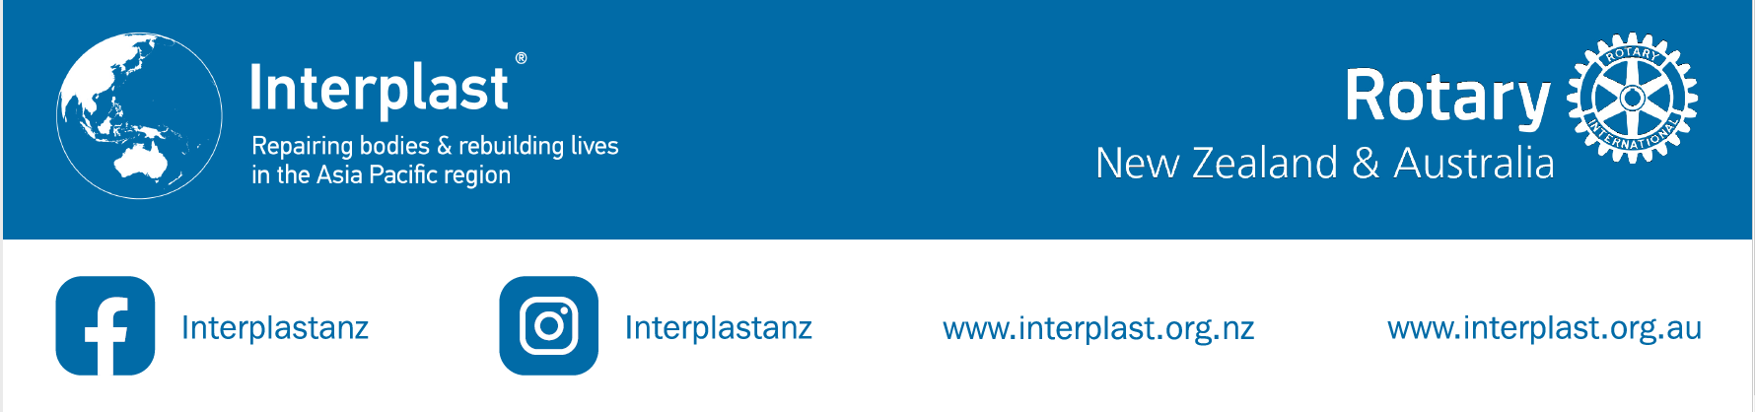
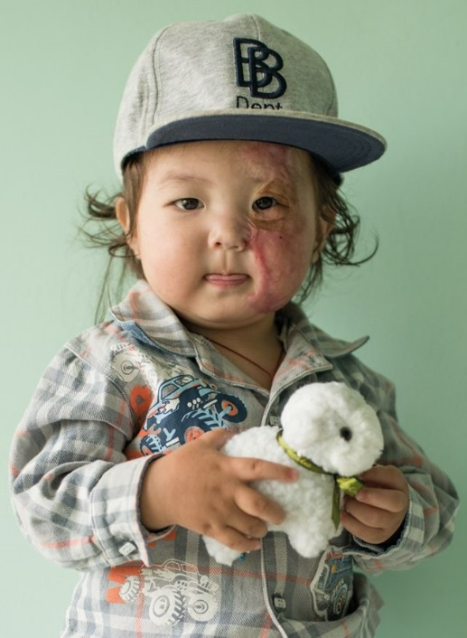
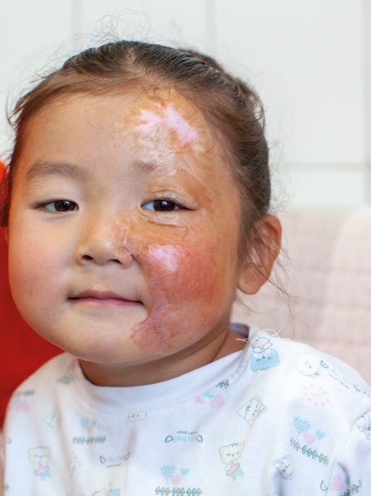
With Rotary's help, Interplast achieved some incredible outcomes across the 4 pillars of our Strategic Plan:
For more information, please contact your Interplast District Chair or Janette at janette.etherington@interplast.org.au
Direct Patient Care
- 75 patients directly benefitted from surgical services, consultations and assistance provided by Interplast
- 50 cleft feeding bottles were delivered to Bhutan to enable babies and children with cleft lips and palates to be able to be fed properly
- Clinical equipment and supplies such as skin graft knives and hemacues were provided to partner hospitals

Training & Mentoring
- 998 clinicians received training via Interplast’s 26 live education webinars
- There were 1456 views of our recorded education sessions online
- Online participants joined from 35 countries and territories
- Over 330 clinicians in Fiji and Nepal were trained on burns care and prevention

Hospital Improvement
- 11 hospitals across the Asia-Pacific are actively engaged in hospital improvement initiatives, focusing on Interplast’s gender and disability inclusion and awareness projects
- These projects aim to improve access to not only Interplast programs, but to hospitals and clinics in general across our partner countries. The projects are essential to our goal of universal access to surgical care

System Strengthening
- A research project in the Pacific focussed on the unacceptably high rates of diabetic foot disease in Pacific Island nations (which often results in the amputation of the affected foot)
- During the year, a number of evaluations of Interplast’s work were commissioned in our partner countries, so that we could assess how effective our services are, and where there is room for improvement.

In Mongolia a Burns Surgery Mentoring and Clinical Services evaluation was carried out.

Little Ankhbayar was one of the patients whose care was reviewed. He had been badly burned as a 14-month old. As the burnt skin healed, it formed severe contractures - so bad that he could not close his left eye, even when he slept.

In 2022 Ankhbayar's mother was happy to report that "now my son sleeps with his eyes completely closed".
Ankhbayar in 2022
What an amazing difference!
Ankhbayar in 2017 before his surgery

